ATAR Course Examination, 2019
Question/Answer Booklet

PHYSICS

Name:__________________________________________

Teacher:_______________________________________

Time allowed for this paper

Reading time before commencing work: ten minutes
Working time for paper: three hours

Material required/recommended for this paper

To be provided by the supervisor

This Question/Answer booklet
Formula and Data booklet

To be provided by the candidate
Standard Items: pens (blue/black preferred), pencils (including coloured), sharpener, correction fluid/tape, eraser, ruler, highlighters

Special Items: non-programmable calculators satisfying the conditions set by the School Curriculum and Standards Authority for this course, drawing templates, drawing compass and a protractor

Important note to candidates
No other items may be taken into the examination room. It is your responsibility to ensure that you do not have any unauthorised notes or other items of a non-personal nature in the examination room. If you have any unauthorised material with you, hand it to the supervisor before reading any further.

Structure of this paper

Section | Number of questions available | Number of questions to be answered | Suggested working time  (minutes) | Marks available | Percentage of examination
Section One  Short response | 11 | 11 | 50 | 54 | 30
Section Two  Problem-solving | 6 | 6 | 90 | 90 | 50
Section Three  Comprehension | 2 | 2 | 40 | 36 | 20
 |  |  |  | Total | 100

Instructions to candidates

1. The rules for the conduct of Western Australian external examinations are detailed in the Year 12 Information Handbook 2019. Sitting this examination implies that you agree to abide by these rules.

2. Write answers in this Question/Answer Booklet.

3. When calculating or estimating answers, show all your working clearly. Your working should be in sufficient detail to allow your answers to be checked readily and for marks to be awarded for reasoning.

In calculations, give final answers to three significant figures and include appropriate units where applicable.

In estimates, give final answers to a maximum of two significant figures and include appropriate units where applicable.

4. You must be careful to confine your responses to the specific questions asked and to follow any instructions that are specific to a particular question.

5. Supplementary pages for the use of planning/continuing your answer to a question have been provided at the end of this Question/Answer booklet. If you use these pages to continue an answer, indicate at the original answer where the answer is continued,
i.e. give the page number.

6. The Formulae and Data booklet is not to be handed in with your Question/Answer booklet.
SECTION ONE: Short Response 30% (54 marks)
This section has 11 questions. Answer all questions. Write your answers in the spaces provided.

When calculating numerical answers, show your working or reasoning clearly. Give final answers to three significant figures and include appropriate units where applicable.

When estimating numerical answers, show your working or reasoning clearly. Give final answers to a maximum of two significant figures and include appropriate units where applicable.

Supplementary pages for the use of planning/continuing your answer to a question have been provided at the end of this Question/Answer booklet. If you use these pages to continue an answer, indicate at the original answer where the answer is continued, i.e. give the page number.

Suggested working time: 50 minutes.

Question 1 (5 marks)
A commercial DC motor has a maximum power rating of 1890 W. It is connected to a 360 V DC supply. When operating at maximum power, the motor draws 10.5 A of current.

(a) Although the voltage supplied to the motor is 360 V, when operating at maximum power, an electrician measures the voltage across the motor to be only 180 V.
(i) Explain this observation. (2 marks)

(ii) Calculate the internal resistance of the DC motor. State an appropriate unit. (3 marks)

Answer ____________ Unit _________
Question 2 (5 marks)

Laptop chargers are traditional transformers that create an alternating current in the secondary coil.
240 V mains supply
3.75 A supplied to laptop
Charger

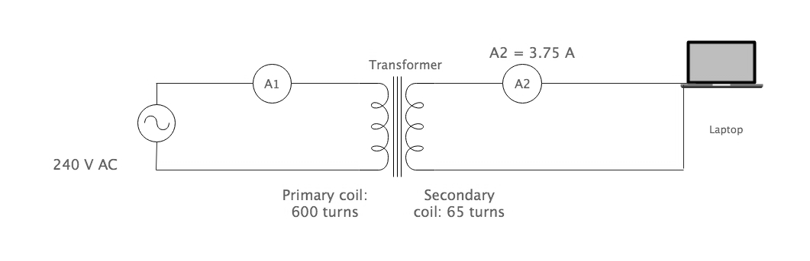
The circuit diagram depicting the above situation is shown below.
(a) Explain briefly how the transformer creates an alternating current in the secondary coil.
(3 marks)
(b) Using information from the diagram, calculate the potential difference that the charger provides to the laptop. (2 marks)

Answer ____________V
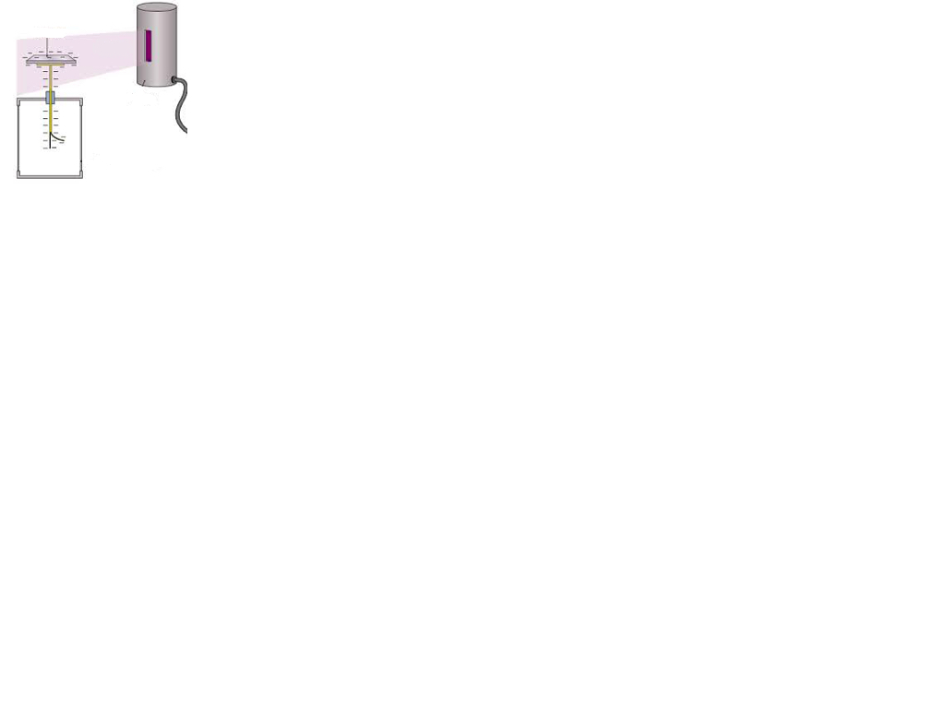
Question 3 (5 marks)
The photoelectric effect can be demonstrated by illuminating a negatively charged electroscope, with ultraviolet (UV) light. A particular electroscope has a zinc metal plate. Once the electroscope was charged, a student switched on an ultraviolet light. After a few seconds, the electroscope was discharged as electrons were emitted from the surface of the zinc.
Zinc plate
gold leaf electroscope
uv lamp
uv light

(a) Would a positively charged electroscope have been discharged in the same way? Explain.
(2 marks)

(b) Calculate the velocity of emitted electrons, if the UV light has a frequency of 1.2 x 10¹⁵ Hz. The work function of zinc is 4.3 eV. (3 marks)

Answer ______________m s⁻¹
Question 4 (5 marks)

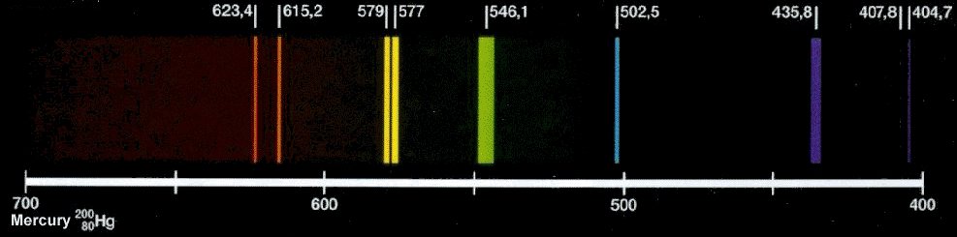
A student observes the spectrum emitted by a mercury vapour lamp and notices that each line has a different colour, as represented by the figure below.

(a) Explain the origin of the different colours observed in the mercury spectrum. (2 marks)

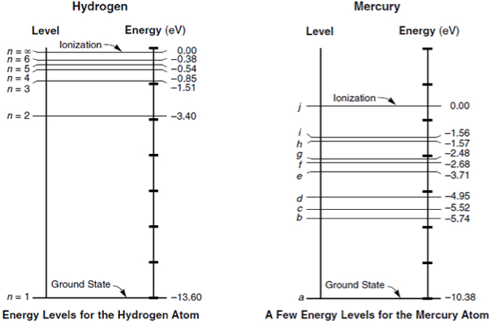
The figure below shows some of the energy levels for atomic mercury.
- 4.76

(b) There is a strong green line of wavelength 546.1 nm.
(i) Show that the photons producing this green line have an energy of 2.28 eV.
(2 marks)

(ii) Show the electron transition that produced this green line on the energy level diagram. (1 marks)
Question 5 (5 marks)
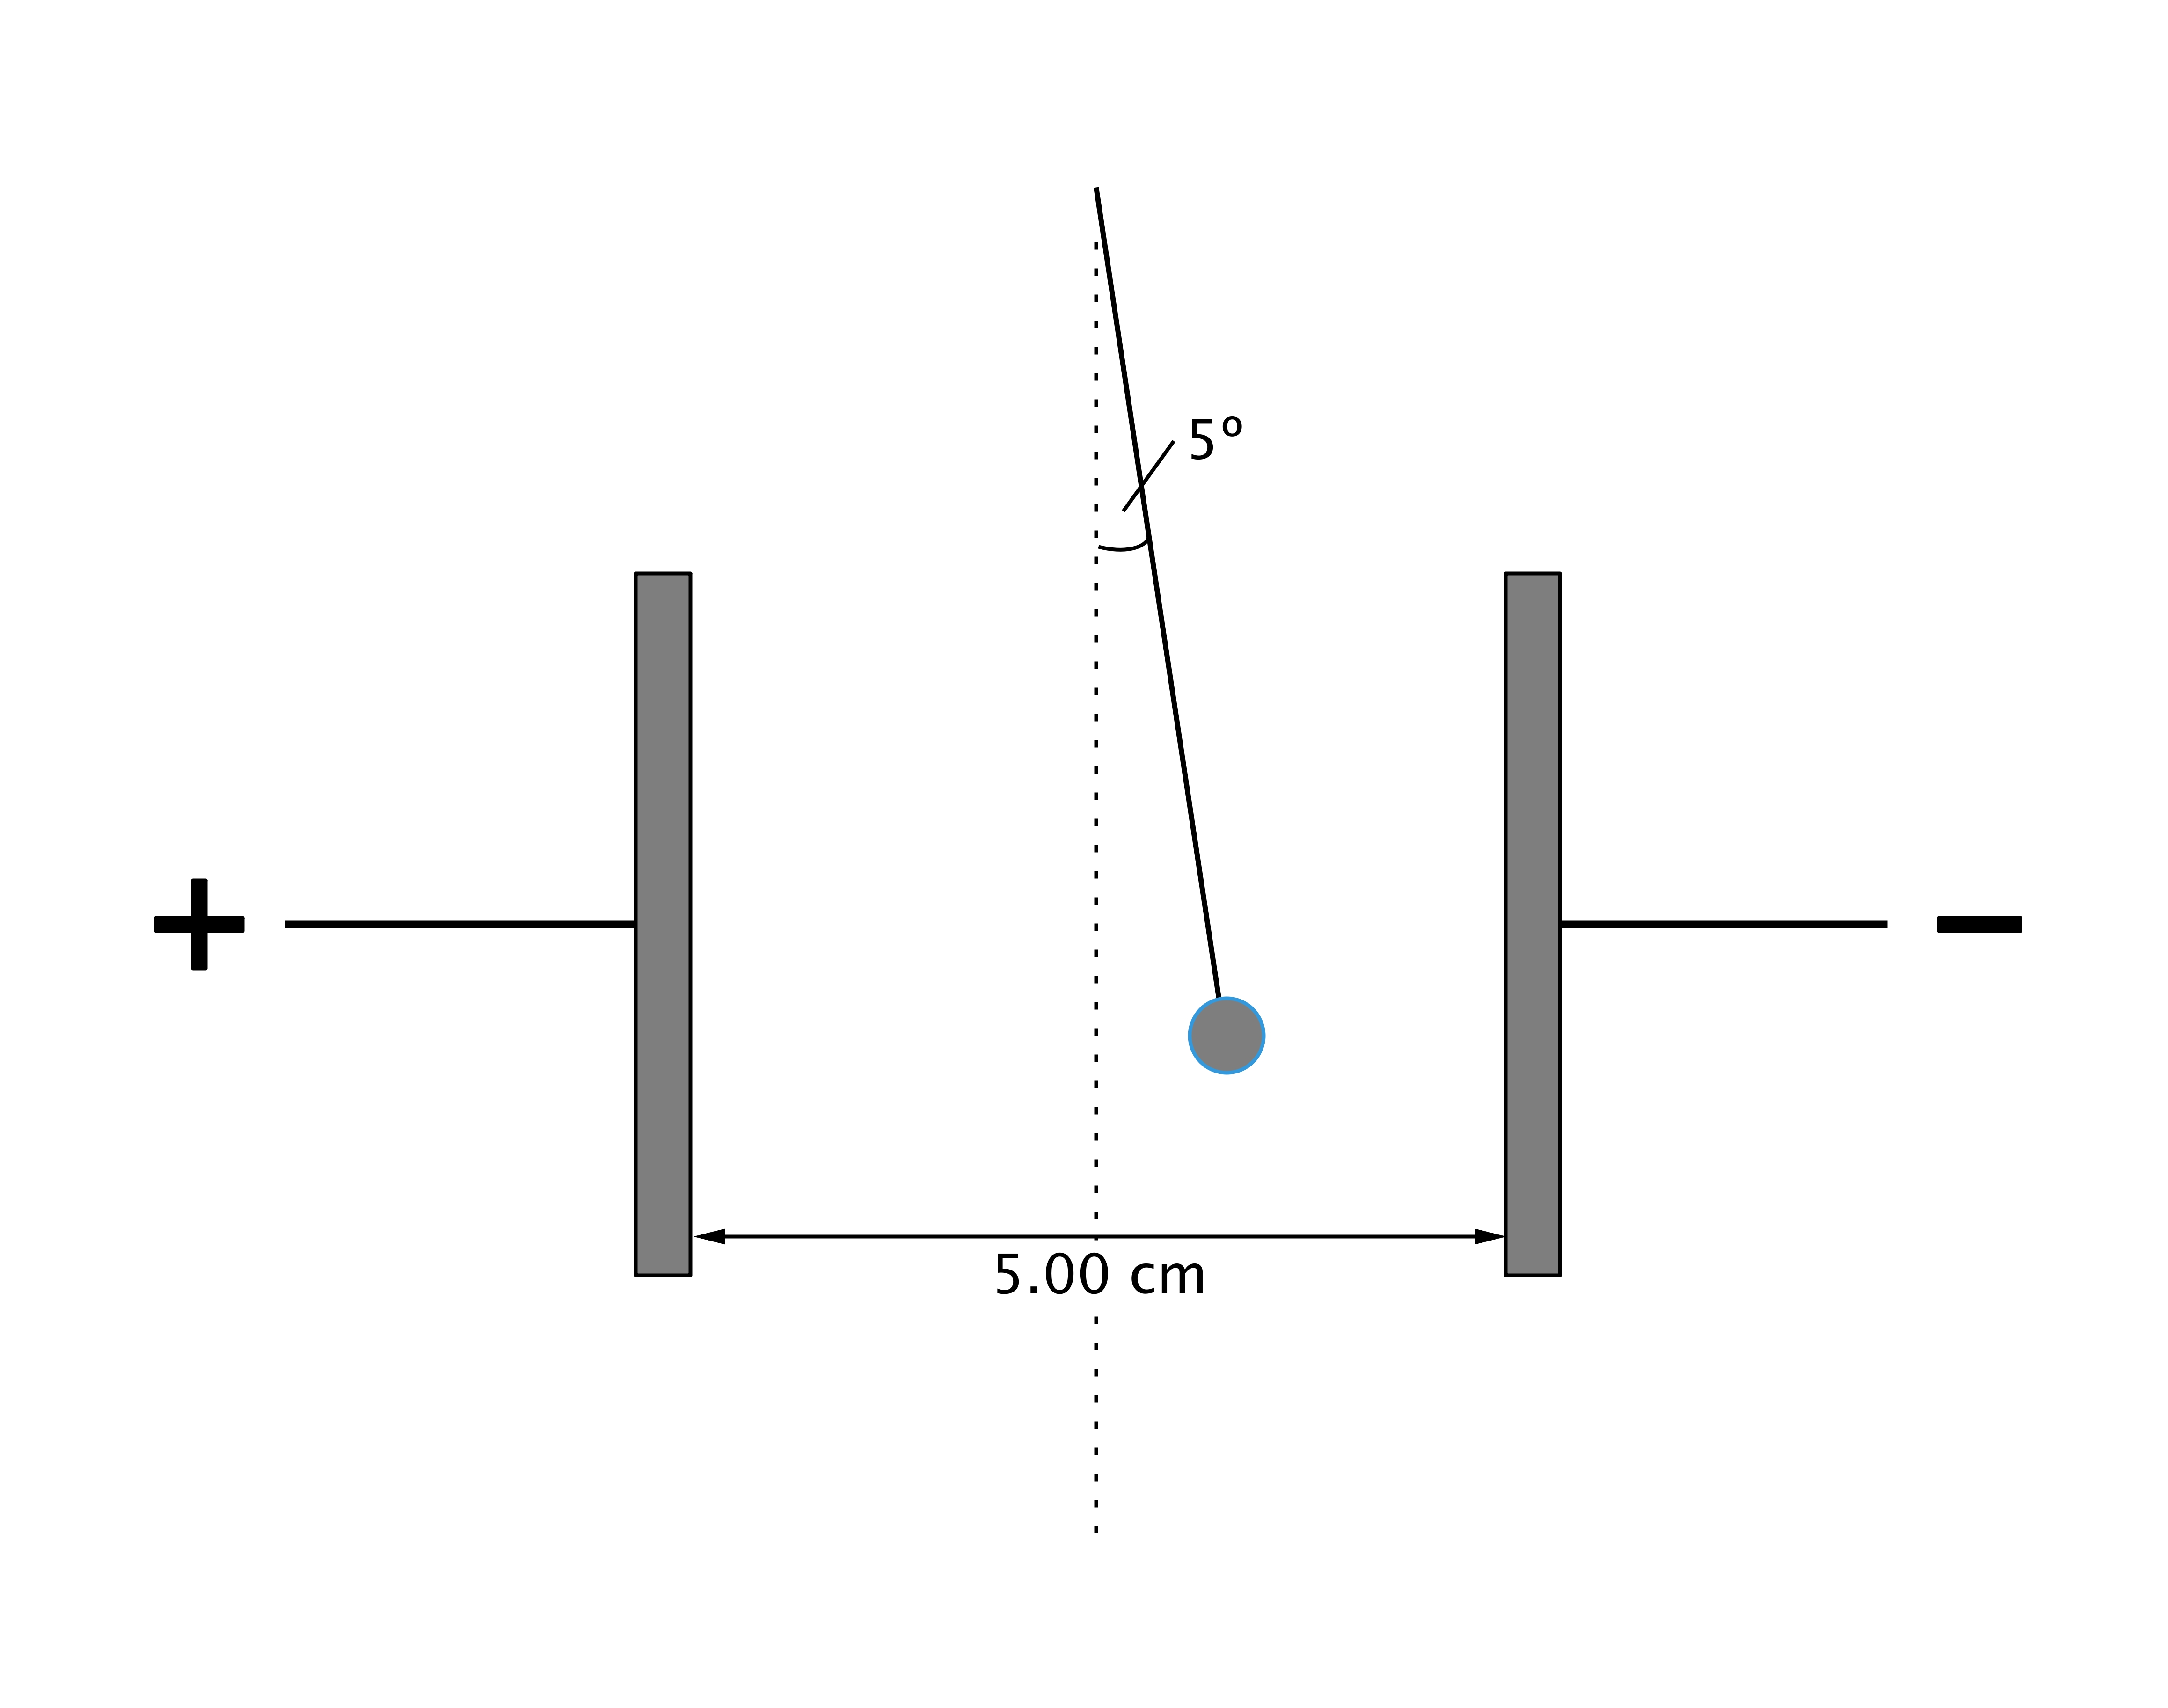
A small charged sphere of mass 2.21 × 10^{–4} kg, suspended from a thread of insulating material, was placed between two vertical parallel plates 5.00 cm apart. When a potential difference of 4150 V was applied to the plates, the sphere moved until the thread made an angle of 5.0° to the vertical, as shown in the diagram below.
(a) Show that the electrostatic force experienced by the charged sphere is given by:
F = mg tan 5º, where m is the mass of the sphere. (2 marks)

(b) Calculate the charge on the sphere. (3 marks)

Answer ____________ C
Question 6 (4 marks)
Evidence to support the Big Bang theory comes from cosmological microwave background radiation and the relative abundance of hydrogen and helium in the Universe.

(a) Explain what is meant by cosmological microwave background radiation and how its existence supports the Big Bang theory. (2 marks)

(b) Explain how the relative abundance of hydrogen and helium supports the Big Bang theory.
(2 marks)

Question 7 (6 marks)
The figure on the left below shows the side view of an electron diffraction tube used to demonstrate the wave properties of an electron. An electron beam is incident on a thin graphite target that behaves like the slits in a diffraction grating experiment. After passing through the graphite target the electrons strike a fluorescent screen. The figure on the right below shows the appearance of the fluorescent screen when the electrons are incident on it.
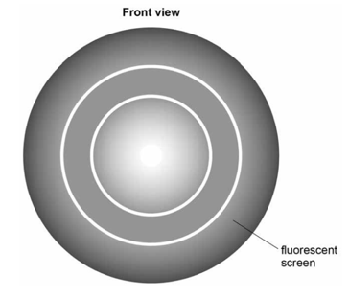
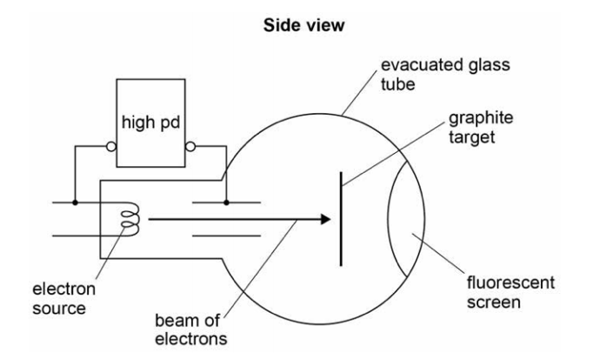

(a) Explain how the pattern produced on the screen supports the idea that the electron beam is behaving as a wave rather than as a stream of particles. (2 marks)

(b) When the electrons strike the graphite target, they have a speed of 2.2 x 10⁷ m s⁻¹.

(i) Calculate the potential difference required to accelerate the electrons to this speed.
(2 marks)

Answer ____________ V

(ii) Calculate the de Broglie wavelength of the electrons as they strike the graphite.
(2 marks)

Answer ____________ m

Question 8 (5 marks)
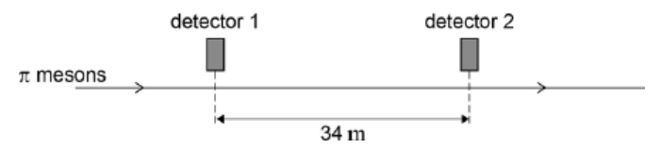
Two detectors are measured to be 34 m apart by an observer in a stationary frame of reference. A beam of π mesons travel in a straight line at a speed of 0.95 c past the two detectors, as shown in the figure below.

(a) Calculate the time taken, in the frame of reference of the observer, for a π meson to travel between the two detectors. (2 marks)

(b) π mesons are unstable and decay with a half-life of 18 ns. It is found in experiments that approximately 75% of the π mesons that pass the first detector decay before reaching the second detector. Show by calculation how this provides evidence to support the theory of special relativity.

* recall from Year 11 Physics that the half-life refers to the time for ½ of a population to decay. The amount remaining after a certain amount of time is given by:
$A= A_{0}{\left(\frac{1}{2}\right)}^{n}$,
where A₀ is the original number of particles and A is the number remaining after “n” half-lives have passed.
(3 marks)

Question 9 (4 marks)
Zocark is an alien who is escaping the Earth at a speed of 0.50 c, relative to the Earth. When Zocark is 1.0 light years from Earth, he fires an unpowered rocket toward the Earth at 0.80 c relative to himself. At the same time he sends a radio message to the Earth warning Earth of the approaching rocket.

Calculate the time difference between the Earth receiving Zocark’s warning and the rocket colliding with the Earth.



Zocark
Earth
unpowered rocket

Answer __________ year(s)
Question 10 (5 marks)

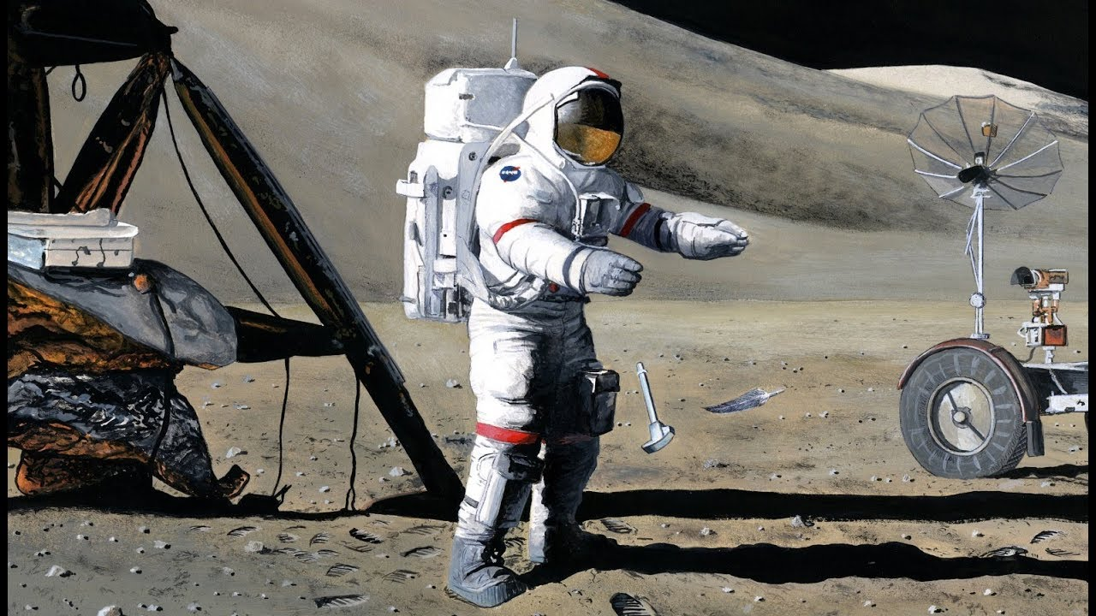
In 1971, Commander David Scott famously dropped a hammer and a feather at the same time on the Moon’s surface during the Apollo 15 mission. It was observed that both objects landed on the Moon’s surface at the same time.

(a) If Commander Scott threw the hammer horizontally at the same time that he released the feather, would they both hit the ground at the same time? Explain. (2 marks)

(b) By making an appropriate assumption, estimate the horizontal distance covered by the hammer if it was thrown horizontally at 5.0 m s⁻¹. (3 marks)

Question 11 (5 marks)

During a lightning strike, there is a negative discharge from a cloud to the ground. This discharge produces a 325 kA current, that falls to 0 A in 50.0 μs. There is a 55 turn coil of radius 0.800 m, placed 225 m from the strike as shown below.

* diagram not to scale
225 m
0.800 m
55 turn coil

(a) Calculate the average emf induced in the coil during this strike. ( 4 marks)

Answer ___________ V

(b) On the diagram indicate the direction of the induced emf in the coil. (1 mark)

End of Section One
SECTION TWO: Problem-solving 50% (90 marks)

This section has six questions. Answer all questions. Write your answers in the spaces
provided.

When calculating numerical answers, show your working or reasoning clearly. Give final answers to three significant figures and include appropriate units where applicable.

When estimating numerical answers, show your working or reasoning clearly. Give final answers to a maximum of two significant figures and include appropriate units where applicable.

Supplementary pages for the use of planning/continuing your answer to a question have been provided at the end of this Question/Answer booklet. If you use these pages to continue an answer, indicate at the original answer where the answer is continued, i.e. give the page number.

Suggested working time: 90 minutes.

Question 12 (12 marks)
The Large Hadron Collider (LHC) uses magnetic fields to confine fast-moving charged particles travelling repeatedly around a circular path. The LHC is installed in an underground circular tunnel of circumference 27 km.

(a) In the presence of a suitably directed uniform magnetic field, charged particles move at constant speed in a circular path of constant radius. By reference to the force acting on the particles, explain how this is achieved and why it happens. (4 marks)

(b) (i) In one particular experiment, the charged particles travelling around the LHC were protons. Calculate the centripetal force acting on a proton when travelling in a circular path of circumference 27.0 km at one-tenth of the speed of light. Ignore relativistic effects. (3 marks)

Force: ___________N
(ii) Calculate the flux density of the uniform magnetic field that would be required to produce this force. State an appropriate unit. (3 marks)

Answer: _________ Units: _______

(c) The Large Hadron Collider is an example of a high energy particle accelerator. Explain the importance of high energy particle accelerators to Physicists. (2 marks)

Question 13 (14 marks)
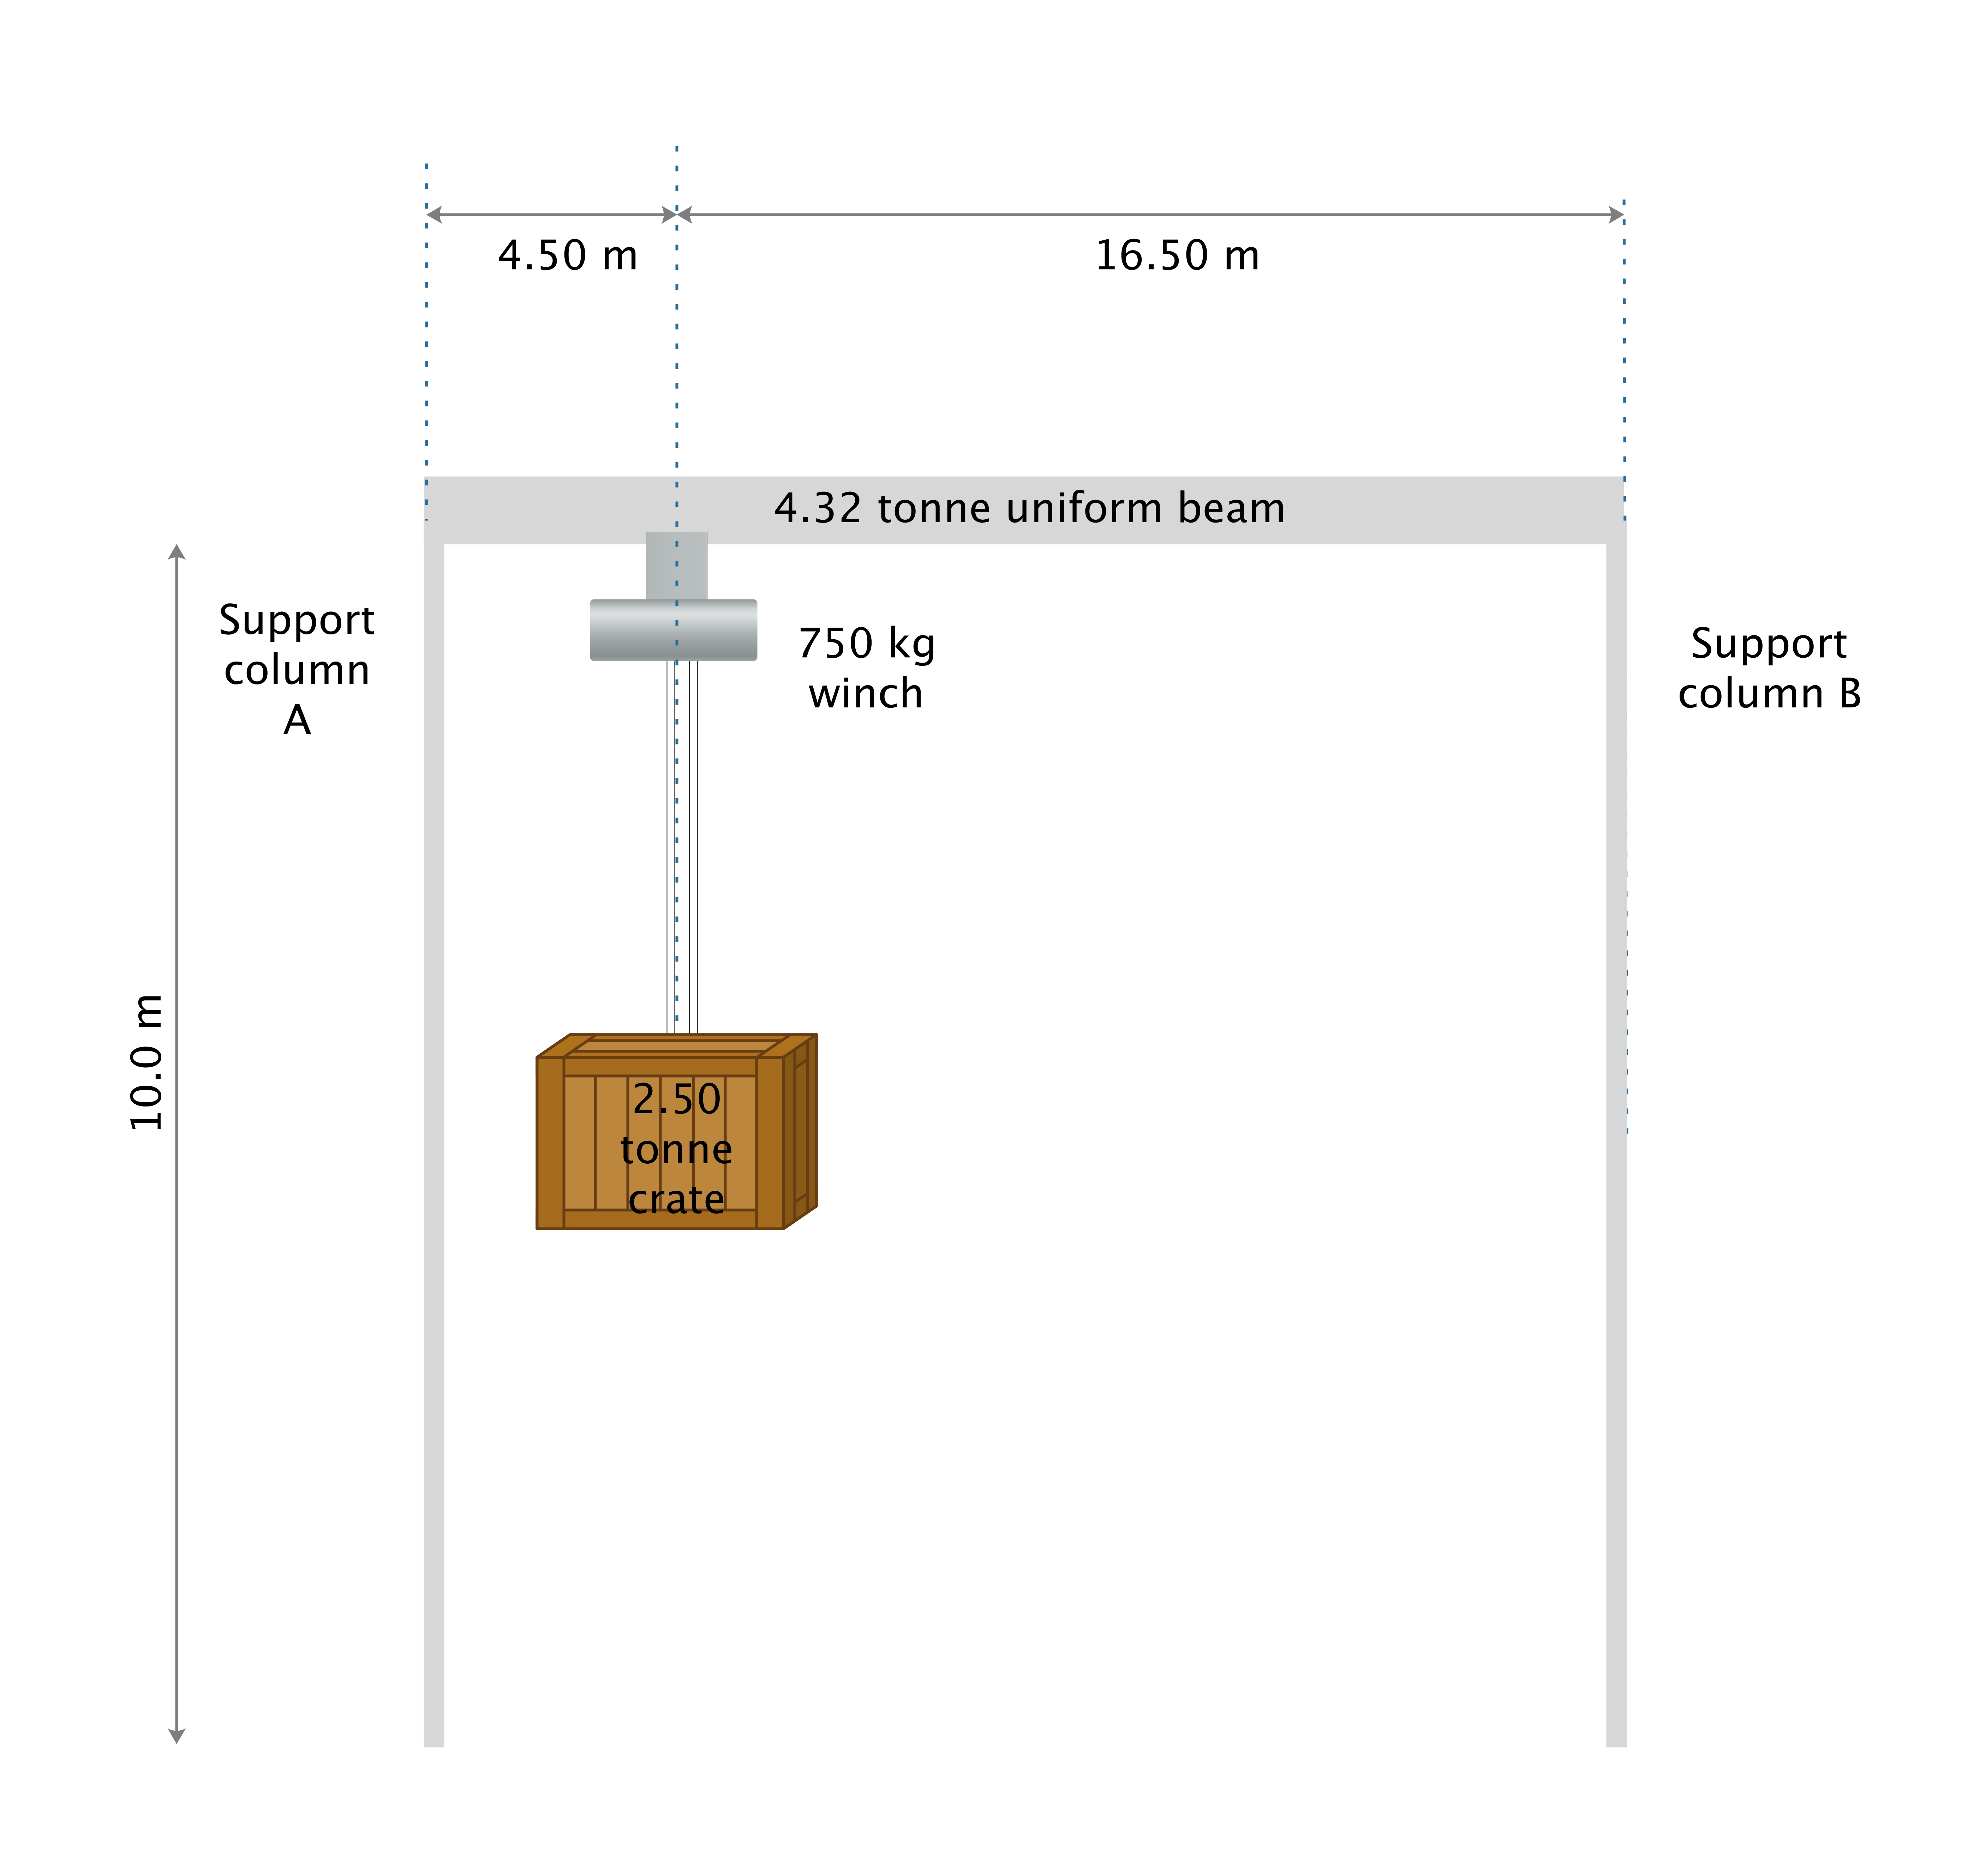
A gantry crane is being used to lift a 2.50 tonne crate as shown in the diagram below. The gantry consists of a 4.32 tonne, 21.0 m uniform beam that is supported by two 10.0 m support columns A and B. The 2.50 tonne crate is 4.50 m from the center of column A and 16.50 m from column B. There is a 750 kg winch whose center of mass is directly above the center of mass the crate.
(a) In the space below, draw a free body diagram of the beam, clearly labelling all forces acting on it. (4 marks)

(b) Calculate the reaction force provided by each column on the beam. (4 marks)

Reaction force from column A: ___________ N
Reaction force from column B: ___________ N
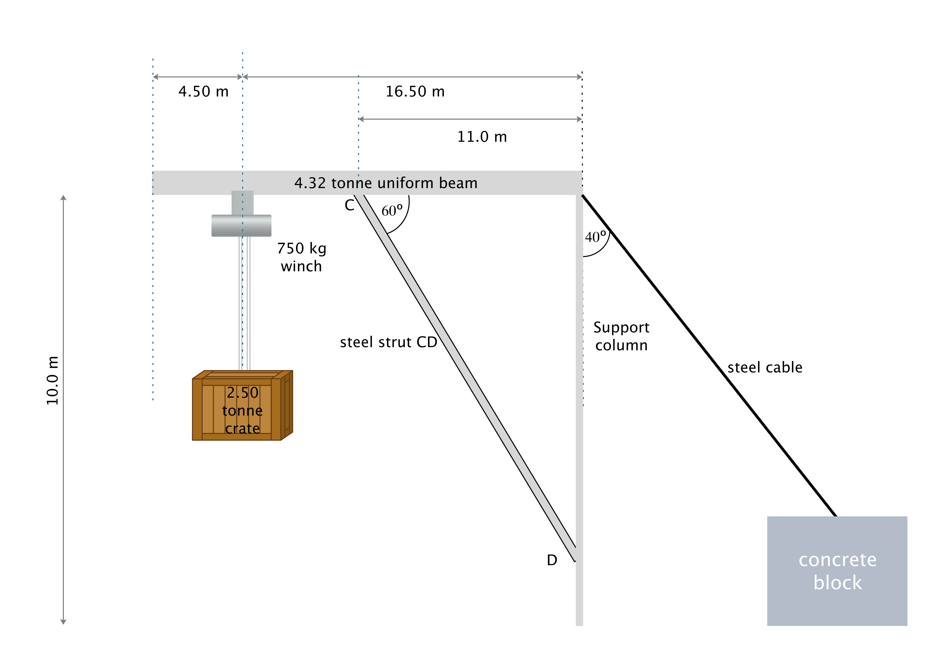
In a variation of the gantry crane, the beam is supported by one column, pivoted at its base and at its point of attachment with the beam, which is held in place by a steel cable attached to a large concrete block. The beam is supported by a 250 kg strut CD which is pivoted at both ends. CD makes an angle of 60º with the beam and is attached 11.0 m from the right hand end of the beam. The cable makes an angle of 40º with the support column.
(c) Calculate the tension in the steel cable. (3 marks)

Answer: _______ N
(d) Calculate the force of compression in strut CD. (3 marks)

Answer: _______ N
Question 14 (17 marks)
A small rectangular coil ABCD contains 140 turns of wire. The sides AB and BC of the coil
are of lengths 4.5 cm and 2.8 cm respectively, as shown in the figure below.

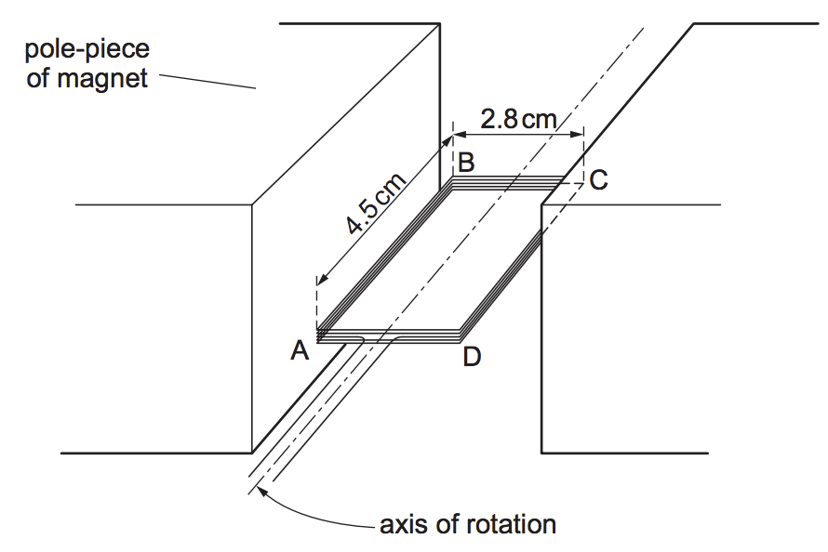
N
S

The coil is held between the poles of a large magnet so that the coil can rotate about an axis through its centre. When the current in the coil is 170 mA and the coil is stationary, the maximum torque produced in the coil is 2.1 × 10^{–3} N m.

(a) Is the position shown, one of minimum or maximum torque? Explain. (2 marks)

(b) For the coil in the position shown calculate the magnitude of the force on
(i) side AB of the coil (2 marks)

Answer __________ N
(ii) side BC of the coil (2 marks)

Answer __________ N
(c) Calculate the strength of the magnetic field experienced by the sides of the coil. (4 marks)

Answer: ____________

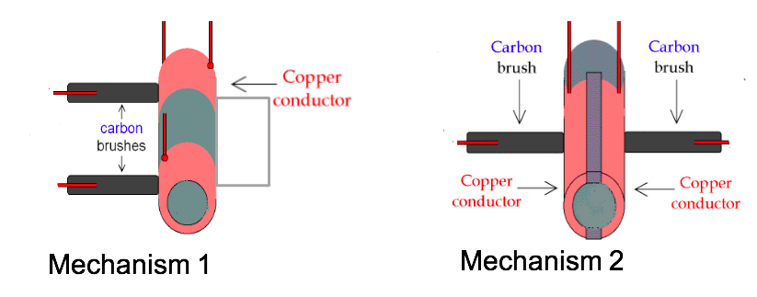
(d) The above diagram does not show how the coil is connected to a potential difference. Of the two mechanisms shown below, which mechanism should be used for the coil to rotate as a DC motor. Name the mechanism and explain your choice. (3 marks)

(e) Once the coil has started rotating as a DC motor, does the maximum torque increase, decrease or remain the same. Explain. (4 marks)

Question 15 (16 marks)
During an experiment, a pendulum is set up, as shown in the diagram. The length of the cord attached to the bob is 1.55 m. The bob has a mass of 1.80 kg and is released from rest from the position shown. At the lowest point of its path, the bob is 7.80 cm beneath its starting point.
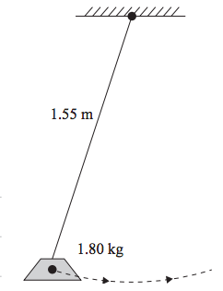
7.80 cm

(a) By considering conservation of energy, calculate the velocity of the bob at its lowest point. (3 marks)

Answer = _______m s⁻¹

(b) Calculate the tension in the cord at the lowest point of its path. (3 marks)

Answer = _______N
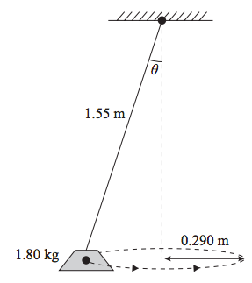
Later, the experimental setup is modified so that the bob swings in a horizontal circular path, with radius 0.290 m, as a conical pendulum.

(c) On the above diagram, indicate all forces acting on the bob as clearly labelled arrows and indicate the direction of the net force on the bob as a dashed arrow ( ). (3 marks)

(d) Show that the tension in the cord is now 18.0 N. (4 marks)

(e) Calculate the magnitude of the velocity of the bob at the position shown. (3 marks)

Answer ______m s⁻¹
Question 16 (16 marks)
Digital television in Australia can be accessed by using a satellite dish pointed at a satellite in
space. The satellite used to transmit the signals appears to stay still relative to the Earth.
The satellite, with a mass of 300 kg, is actually travelling around the Earth in a geostationary orbit.

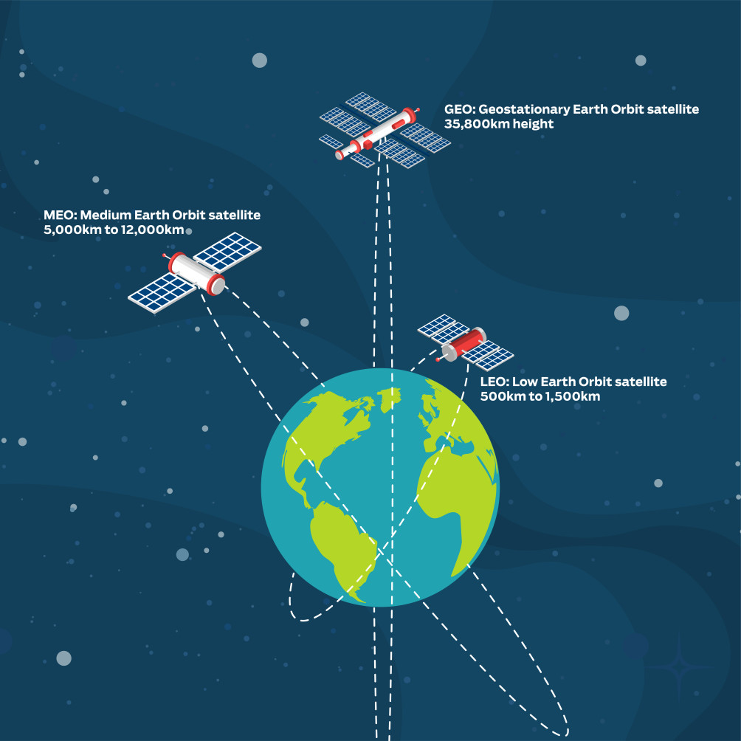
The picture below show the three main types of satellite orbits. Low Earth Orbits (LEO), Medium Earth Orbits (MEO) and Geostationary Earth Orbits (GEO).
GEO: Geostationary Earth Orbit satellite 35,800 km height.
LEO: Low Earth Orbit satellite 500 km to 1,500 km height.
MEO: Medium Earth Orbit satellite 5,000 km to 12,000 km height.

(a) In the picture, there is an error with the indicated orbit a GEO satellite. Indicate this error and explain why the orbit shown must be an error. (3 marks)

(b) Which of these satellites experiences the greatest gravitational force from the Earth? Circle the correct answer from the choices below. Explain your answer in the space provided.
(3 marks)

LEO MEO GEO All satellites experience the same force

Explanation

(c) Which of these satellites is travelling at the greatest speed relative to the Earth? Circle the correct answer from the choices below. Explain your answer in the space provided.
(3 marks)

LEO MEO GEO All satellites have the same speed

Explanation

(d) Kepler’s Third Law is given on your data sheet. By using relevant equations, in the space below, derive Kepler’s Third Law. (3 marks)

(e) Using the information in the picture, calculate the minimum period of a LEO satellite. Provide your answer in minutes and seconds. (4 marks)

Answer: ___________ minutes and _____________ seconds

Question 17 (15 marks)

The equation below represents the collision of a neutral kaon meson with a proton baryon, resulting in the production of a neutron and a positive pion meson.

$$K^{o}+p→n+ π^{+}$$

(a) Show how baryon number, lepton number and charge are conserved in this interaction. (3 marks)

 | Kº | p | n | π⁺
Baryon number
Lepton number
Charge

(b) Given that the neutral kaon has a strangeness of +1. Give the quark structure of the following particles. (4 marks)

Kº __________
p __________

n __________

π⁺ ______________

(c) Name the interaction and gauge boson involved in this interaction? (2 marks)

Interaction: _______________

Gauge boson: _______________

(d) Another strange particle X, decays in the following way:

X → π⁻ + p

(i) What is the charge of X? Explain your answer. (2 marks)

(ii) Deduce whether X is a baryon, meson or lepton. Explain your choice. (2 marks)

(iii) Which of the three particles involved in this interaction is the most stable? Explain.
(2 marks)

End of Section Two

SECTION THREE: Comprehension 20% (36 marks)

This section has two (2) questions. You must answer both questions. Write your answers in the spaces provided.
When calculating numerical answers, show your working or reasoning clearly. Give final answers to three significant figures and include appropriate units where applicable.
When estimating numerical answers, show your working or reasoning clearly. Give final answers to a maximum of two significant figures and include appropriate units where applicable.
Additional working space pages at the end of this Question/Answer booklet are for planning or continuing an answer. If you use these pages, indicate at the original answer, the page number it is planned/continued on and write the question number being planned/continued on the additional working space page.

Suggested working time: 40 minutes.

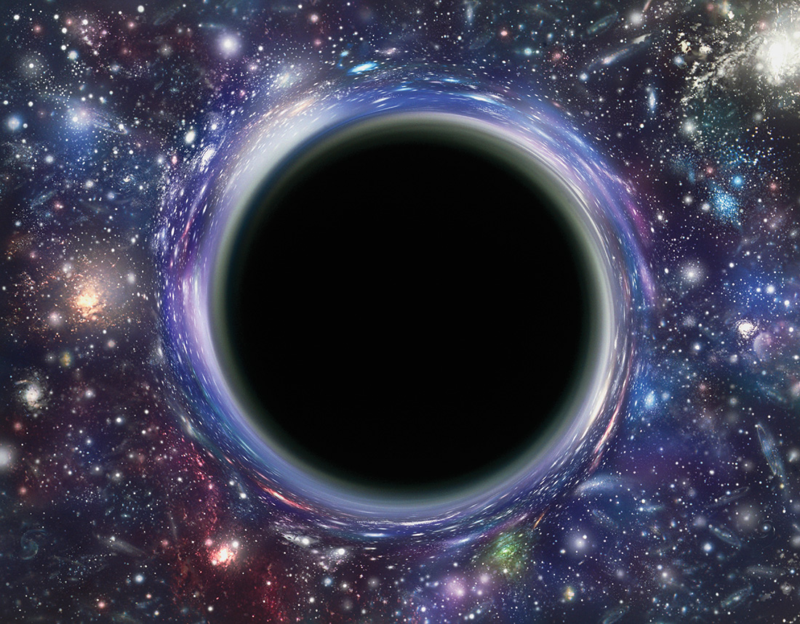
Question 18 (18 marks)
Escape velocity and The Black Hole
Article adapted from Fundamentals of Modern Physics by Peter J Nolan. 2014
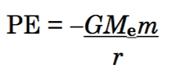
The simplest way to describe the black hole is to start with a classical analogue. Suppose we wished to launch a rocket from the earth to a far distant place in outer space. How fast must the rocket travel to escape the gravitational pull of the earth? This value is known as the Escape Velocity. When we launch the rocket it has a velocity v, and hence, a kinetic energy. As the rocket proceeds into space, its velocity decreases but its potential energy increases. The absolute potential energy of an object when it is a distance r away from the center of the earth is found from:
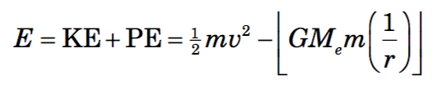
where G is the universal gravitational constant, Me is the mass of the earth, and m is the mass of the object. Let us now apply this potential energy term to a rocket that is trying to escape from the gravitational pull of the earth. The total energy of the rocket at any time is equal to the sum of its potential energy and its kinetic energy, that is:

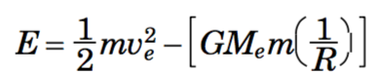
When the rocket is fired from the surface of the earth, r = R, at an escape velocity v_{e} , its total energy will be:

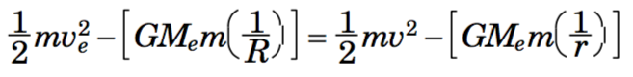
By the law of conservation of energy, the total energy of the rocket remains a constant. Hence, we can equate the total energy at the surface of the earth to the total energy when the rocket is far removed from the earth. That is:

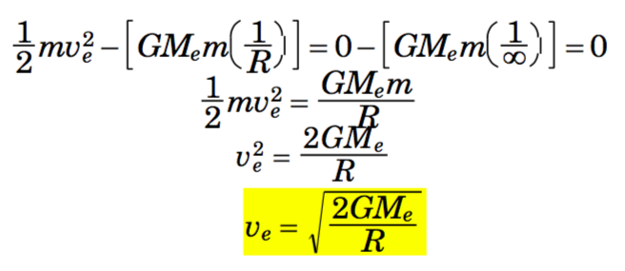
When the rocket escapes the pull of the earth it has effectively traveled to infinity, that is, r = ∞, and its velocity at that time is reduced to zero, that is, v = 0. Hence, the equation reduces to:
If we substitute v_{e} for the c, the speed of light and rearrange, we get a formula that tells us the maximum radius of any object with mass, for light to be able to escape from it.
$$R_{S}= \frac{2GM_{e}}{c^{2}}$$
This value is called the Schwarzchild Radius and any distance to an object closer than this value is said the be within the Event Horizon, a region from which nothing, not even light can escape!
The reason for the name, black hole, comes from the idea that if we look at an object in space, such as a star, we see light coming from that star. If the star became a black hole, no light could come from that star. Hence, when we look into space we would no longer see a bright star at that location, but rather nothing but the blackness of space. There seems to be a hole in space where the star used to be and therefore we say that there is a black hole there.
Solving the Schwarzschild radius of the sun, by replacing the mass of the earth by the mass of the sun, we get 2.95 x 103 m. Thus, if the sun were to contract to a radius below 2.95 x 103 m the gravitational force would become so great that no light could escape from the sun, and the sun would become a black hole.

(a) Explain the relationship between the concept of escape velocity and the concept of a black hole. (2 marks)

(b) The article states that:
“When the rocket escapes the pull of the earth it has effectively travelled to infinity, that is, r = ∞, and its velocity at that time is reduced to zero, that is, v = 0.”
(i) Use Newton’s Law of Universal Gravitation to support the argument that at r = ∞, the rocket has escaped the pull of the Earth. (2 marks)

(ii) If an object left the Earth with the minimum escape velocity, why would this value be zero, when r is equal to infinity? (2 marks)
(c) (i) Show that the escape velocity for an object to leave the Earth’s gravitational pull is equal to 1.12 x 10⁴ m s⁻¹. (2 marks)
(ii) Show that the total energy of 12.0 tonne space craft launched at its escape velocity from the surface of the Earth is zero. (3 marks)

(iii) At what speed would this space craft be travelling in deep space at a distance of 325 million kilometres from the Earth? (3 marks)

Speed ________ m s⁻¹
(d) One of the largest stars in our galaxy is Betelgeuse. This star has a radius 887 times that of our Sun and a mass 11.6 times that of our Sun. Explain what is meant by the Schwarzschild radius for this star and calculate is value. (4 marks)

Schwarzschild radius: _____________

Question 19 (18 marks)

Antihydrogen Antics
Article adapted from: https://www.physicscentral.com/explore/action/antics.cfm
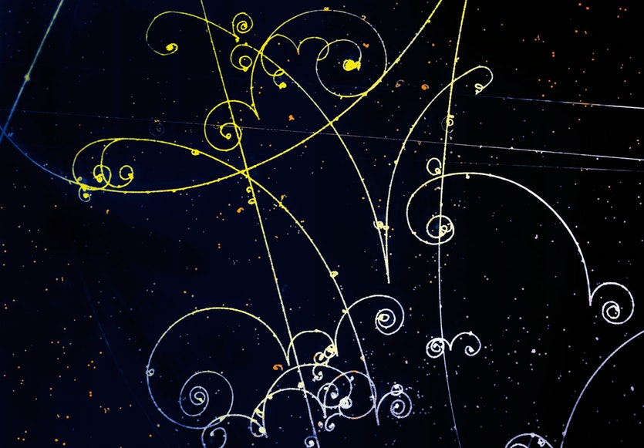
As Star Trek fans know well, the fuel for warp drive is antimatter. No science fiction stuff this—antimatter was predicted by Paul Dirac in 1928. At the time, the only known elementary particles were the positively charged proton and the negatively charged electron. Dirac combined the recently discovered quantum physics with special relativity and produced an equation that seemed to predict two kinds of particles: those with positive energies, as expected, and those with negative energies, which didn’t make any sense. After pondering this result for several years, Dirac realized that these negative energies actually correspond to “antiparticles” of positive energy with the same mass as protons and electrons but with opposite charge. More broadly, he theorized that for every particle there should exist a corresponding antiparticle.

Particle tracks in a cloud chamber
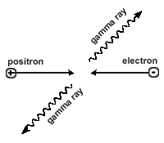
Positron-electron annihilation, before and after: Before, a positron and an electron approach each other. After, the two have annihilated into two gamma rays.
As Dirac was working out the significance of his equation, experimentalists were investigating particles of higher and higher energies. In those days there were no machines to accelerate particles, so investigators turned to Mother Nature. Raining down on Earth from all distant parts of the universe are particles called cosmic rays, which hit the atmosphere and set off a shower of secondary particles. A young physicist at Caltech, Carl Anderson, unaware of Dirac’s prediction, observed these particles by studying their tracks as they moved in a magnetic field. (See photo) One day Anderson noticed tracks that seemed to correspond to a positively charged electron. After doing more experiments to confirm this result, he reported in 1932 the existence of the positron, with the same mass as an electron but a positive charge. Only much later, in the 1950s, did physicists find the much more massive antiproton, because its discovery required a powerful particle accelerator.
When particles and antiparticles meet, they mutually annihilate. An electron and positron annihilate into two gamma ray photons as shown in the diagram, and the gamma rays carry away the mass-energy of the particles according to E = mc². For a proton and antiproton, annihilation produces four particles called pions. So the signature of antihydrogen annihilation is four pions and a pair of gamma rays, all coming from the same place, and with the right directions and energies.

Research
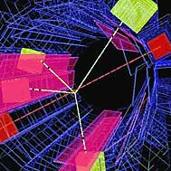
With the discovery of the positron and antiproton, physicists dreamed of combining them to make anti-hydrogen, the simplest atom made of antimatter. Examining how anti-hydrogen absorbs and emits light would permit a stringent test of particle theory, which says that anti-hydrogen’s energy spectrum should be identical to that of ordinary hydrogen.
An atom of anti-hydrogen annihilates to form two gamma rays and two pions. From observations of these annihilation products, physicists constructed this computer image. (image courtesy of CERN)

Physicists first produced antihydrogen at the CERN and Fermilab particle accelerators in the mid-1990s. A beam of antiprotons smashed into a target, creating many new particles, including electron-positron pairs. A few antiprotons and positrons did combine each day, but the best the experimenters could do was detect the antimatter atoms as they raced away at almost the speed of light.
But physicists want to study the antihydrogen, not just detect it, and to do this they need a large, confined sample. The challenges start with the production of the antiprotons, which requires extremely high energies, so once produced, these particles must be decelerated in what is essentially a particle accelerator run backwards. Then the antiprotons enter a series of electric and magnetic traps, cooling them considerably more. In a parallel part of the experiment, positrons from radioactive decay are themselves trapped and cooled.
When positrons and antiprotons finally meet, in yet another trap, some combine to form antihydrogen. Since atoms, including those of antimatter, are electrically neutral, they no longer respond to the electric and magnetic fields and simply fall out of the trap and into annihilation on one of the metal electrodes. From the annihilation products, physicists detect atoms of antihydrogen, as shown in the computer image. The experiment yields about 50,000 antihydrogen atoms, starting from about 1.5 million antiprotons. This sample size is still too small for spectroscopy, but future experiments will increase the yield substantially.
Beyond the study of antimatter for its own sake, these investigations could help cosmologists understand the early history of the universe. The Big Bang should have produced matter and antimatter in equal amounts, but the observed universe seems to be made of only matter. The answer to the question of the missing antimatter could lie in some yet-to-be-discovered difference between hydrogen and antihydrogen.

(a) Briefly outline Paul Dirac’s contribution to our understanding of antimatter. (2 marks)

(b) Carl Anderson studied the tracks of electrons and positrons as they moved in a magnetic field as shown in the picture. State one similarity and one difference in the paths that he would have observed. (2 marks)

Similarity: ___________________________________

Difference: ___________________________________

(c) Explain why the particles spiral inward as can be seen in the picture. (2 marks)

(d) Carl Anderson used cosmic rays created in our atmosphere as his main source of electrons and positrons. Why would he not have observed protons and antiprotons?
(2 marks)

(e) Calculate the amount of gamma energy released when a positron and an electron annihilate each other. Give your answer in eV. (3 marks)

Answer: ___________ eV
(f) The article states that:
“For a proton and antiproton, annihilation produces four particles called pions. So the signature of antihydrogen annihilation is four pions and a pair of gamma rays, all coming from the same place, and with the right directions and energies”.

Explain why:

(i) They must come from the same place. (1 mark)

(ii) They must have the right directions. (1 mark)

(iii) They must have the right energies. (1 mark)

(g) The emission spectrum of normal hydrogen is well understood. How do Scientists expect the emission spectrum of antihydrogen to compare with the that of Hydrogen? (1 mark)

(h) Explain why the atomic spectrum of antihydrogen is yet to be studied. (1 mark)

(i) Briefly explain how the study of antihydrogen could help cosmologists understand the beginning of the universe. (2 marks)

End of Questions
Additional Working Space

Question number: _________

Additional Working Space

Question number: _________

Acknowledgements:
Picture of Earth Satellites:
https://assets.pcmag.com/media/images/600043-leo-meo-geo-satellite-orbital-heights.jpg?thumb=y

Antihydrogen Antics
Article adapted from: https://www.physicscentral.com/explore/action/antics.cfm

Escape velocity and The Black Hole
Article adapted from Fundamentals of Modern Physics by Peter J Nolan. 2014

